Exercise 4: Arrange-Act-Assert (AAA) Pattern, Test Fixtures, Setup and Teardown Methods in JUnit Scenario: You need to organize your tests using the Arrange-Act-Assert (AAA) pattern and use setup and teardown methods.

## Steps:

1. Write tests using the AAA pattern.

2. Use @Before and @After annotations for setup and teardown methods

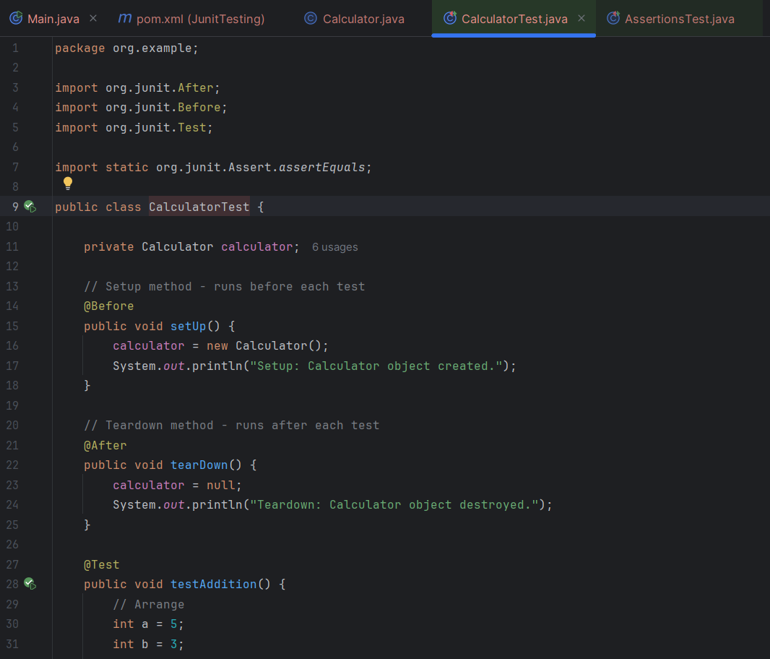

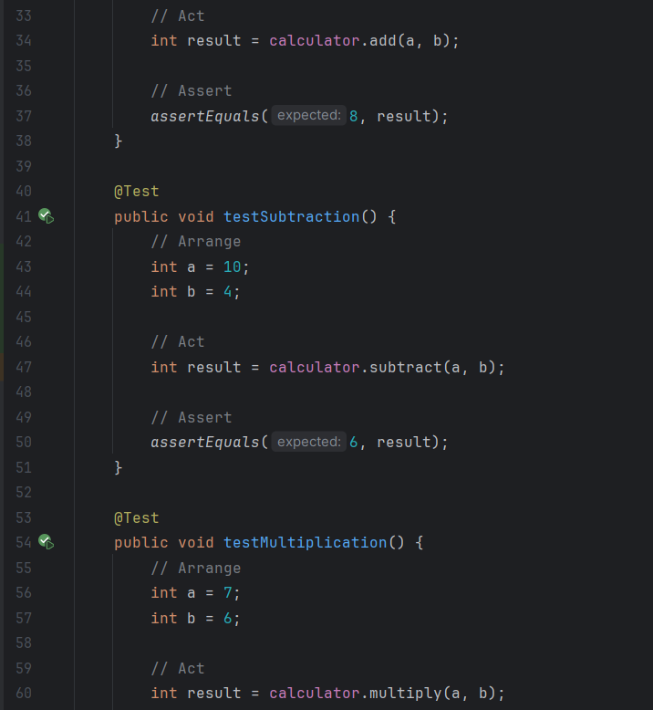

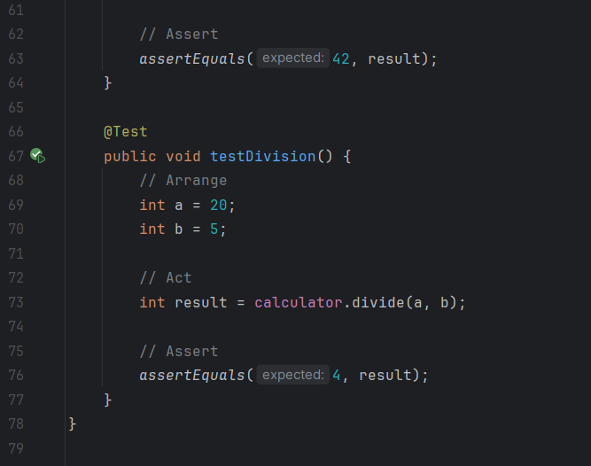

Output –

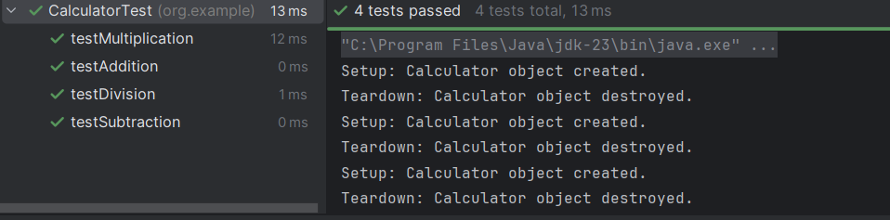

# **Teardown Methods in JUnit**

In JUnit testing frameworks, teardown methods are an essential component of the test lifecycle management. They are used to **clean up resources, reset configurations, or perform necessary de-initialization tasks** after the execution of each individual test case.

Proper use of teardown methods ensures **test isolation**, where the outcome of one test does not impact others, thereby maintaining the reliability and accuracy of the test suite.

### Purpose of Teardown Methods

The primary objectives of teardown methods are:

* To **release system resources** such as memory, files, database connections, or network sockets.
* To **reset the state** of objects to prevent test interdependency.
* To ensure **consistent and repeatable test execution.**